Core Outcome Set-STAndardised Protocol Items: the COS-STAP Statement
TITLE/ABSTRACT
Title 1a
A Protocol for the Development of Core Outcome Sets in Pelvic Organ Prolapse Research
Abstract 1b
Background
The high prevalence of symptomatic pelvic organ prolapse (POP) and the women's lifetime risk of requiring surgery, as well as the significant impact of POP on women’s health related quality of life has resulted in a variety of studies on POP interventions. Randomized trials evaluating treatments for POP have reported a diversity of outcomes and used various outcome measures. Such variation results in an inability to compare and combine individual studies, limiting the value of research and the impact of research-based evidence on informing clinical practice.
The development and use of a core outcome set (COS) would help to address these issues ensuring outcomes important to all stakeholders, primarily women with POP. We aim to produce, disseminate and implement a COS for POP.
Methods
A steering group, within CHORUS, an International Collaboration for Harmonising Outcomes, Research and Standards in Urogynaecology and Women’s Health, including healthcare professionals, researchers and women with POP will guide the development of this COS. Potential outcomes will be identified through comprehensive literature reviews. These outcomes will be entered into an international, multi-perspective online Delphi survey. The modified Delphi method encourages stakeholder group convergence towards consensus core outcomes.
Discussion
Dissemination and implementation of a COS within an international context will be promoted and reviewed. Embedding the COS for POP within future clinical trials, systematic reviews, and clinical practice guidelines could make a profound contribution to advancing the value of research in informing and guiding clinical practice, enhancing patient care and improving outcomes. The infrastructure created by developing a COS for POP could be leveraged in other settings, for example, further advancing research priorities and clinical practice guideline development.

INTRODUCTION
Background and objectives
2a Describe the background and explain the rationale for developing the COS, and identify the
reasons why a COS is needed and the potential barriers to its implementation
Patient centered high-quality care should be based on the best available research evidence. However, research quality and outcomes are highly variable. It has been estimated that most research findings are false. Furthermore 85% of research funding is wasted in the design and reporting of clinical trials as well as other types of research. Waste is evident in all stages of production and reporting and is related to the inclusion of low priority outcomes, inappropriate study design that may lack consideration of existing evidence, selective reporting, publication bias and concealment of planned study outcomes. Although this mainly refers to clinical trials, such issues are expected to feature in other types of research as well.
In pelvic organ prolapse (POP) research, several issues around quality of evidence have been highlighted particularly in Cochrane reviews. For example, in surgery for women with posterior prolapse, evidence quality was found to range from very low to moderate. The same findings were reported in other Cochrane reviews on pelvic organ prolapse treatments.
Although randomized trials have been a research priority, the collection and reporting of outcomes and the selection of outcome measures has been largely overlooked. The consequence of this is a variety of differing outcomes that make drawing conclusions across a group of studies through systematic reviews and meta-analyses difficult, and sometimes, impossible. For example, the majority of POP trials have not evaluated the safety of potential treatments, particularly over the long term. Even in the unlikely situation where outcomes have been consistently collected across trials, evidence synthesis can be limited by the use of different definitions and measurement instruments. The development and use of a minimum set of well-defined, discriminatory, and feasible outcomes, termed a core outcome set (COS), would help to address these issues. COS are data sets that can be measured in a standardized manner and reported consistently.

2b Describe the specific objectives with reference to developing a COS
Scope
- Improving clinical guidelines and patient care
- Avoidance of inconsistencies in outcome selection, measurement and reporting
- Ensuring the inclusion of consistent outcomes when designing studies

3a Describe the health condition(s) and population(s) that will be covered by the COS
Pelvic organ prolapse appears following the loss of vaginal or uterine support and is seen in up to 30-76% of women presenting for routine gynaecology care. Women suffering from this condition would benefit from accurate reporting guided by the existence of a COS.
3b Describe the intervention(s) that will be covered by the COS
Given the current flaws documented in published reviews there is an urgent need for development of effective interventions to reduce the impact of POP on women's quality of life.
Types of interventions covered by the COS:
Conservative treatment for pelvic floor disorders
Pharmacologic Approach to Voiding Disorders
Behavioral Strategies
Biofeedback and functional electrical stimulation
Supportive devices
Surgery for disorders of pelvic support
Repair of the anterior, central and posterior pelvic floor compartment

3c Describe the context of use for which the COS is to be applied
The development and use of a COS for pelvic organ prolapse would help to address the inability to compare and combine studies due to reported outcomes variations, enhancing the value of research to inform clinical practice.

METHODS
Stakeholders 4 Describe the stakeholder groups to be involved in the COS development process, the nature of and rationale for their involvement and also how the individuals will be identified; this should cover involvement both as members of the research team and as participants in the study
Key stakeholders including urogynaecologists, gynaecologists, colorectal surgeons, urologists, general practitioners, researchers, policy makers, industry representatives, professional societies representatives and public and patients (women with POP) will be invited to participate in different stages of COS development. Participants will be asked to register online, provide demographic details, and commit to all rounds. They will be allocated a unique identifier, which will anonymise their responses.
Information sources
5a Describe the information sources that will be used to identify the list of outcomes. Outline the methods or reference other protocols/papers
We conducted previous work related to POP research that will be used to create the list of outcomes.
de Mattos Lourenço TR, Pergialiotis V, Durnea C, et al. A systematic review of reported outcomes and outcome measures in randomized controlled trials on apical prolapse surgery. Int J Gynaecol Obstet. 2019 Apr;145(1):4-11.

de Mattos Lourenco TR, Pergialiotis V, Duffy JMN, et al. A systematic review on reporting outcomes and outcome measures in trials on synthetic mesh procedures for pelvic organ prolapse: Urgent action is needed to improve quality of research. Neurourol Urodyn. 2019 Feb;38(2):509-524.

Durnea CM, Pergialiotis V, Duffy JMN, et al. A systematic review of outcome and outcome-measure reporting in randomised trials evaluating surgical interventions for anterior-compartment vaginal prolapse: a call to action to develop a core outcome set. Int Urogynecol J. 2018 Dec;29(12):1727-1745.

Systematic literature searches (PubMed, EMBASE, Cochrane) will be also conducted to find any additional reported outcomes.

5b Describe how outcomes may be dropped / combined, with reasons
Patient-reported outcome measures can be collected from individual questionnaires items. Systematic reviews of the published academic literature will be carried in order to build outcome domains. Analysis at both individual and combined level is required to limit reporting inconsistency.

Consensus process
6 Describe the plans for how the consensus process will be undertaken
Consensus definition
7a Describe the consensus definition
Consensus status | Description | Criteria
Consensus achieved | Classify as a core outcome | Over 70% of participants in each stakeholder group score this outcome domain 'critical' AND
 |  | Less than 15% of participants in each stakeholder group score outcome domain 'not important'.
Consensus not achieved | Do not classify as a core outcome | Over 70% of participants in each stakeholder group score outcome domain 'not important' AND
 |  | Less than 15% of participants in each stakeholder group score outcome domain 'critical'.
No consensus | Do not classify as a core outcome | Anything else

7b Describe the procedure for determining how outcomes will be added/combined/dropped from
consideration during the consensus process
A meeting conducted by an independent coordinator will be organized with the purpose of deciding which outcomes will be evaluated and included in the COS. In addition, outcomes that do not meet core outcome criteria will be discussed. This meeting will purposefully include various points of views from participants who have completed all rounds of the Delphi survey. During the consensus meeting, the results from each round of the Delphi survey will be presented. To avoid biased consensus formation amongst a group of varied participants, the steering committee will consider all opinions in an interactive meeting. To facilitate dissemination and implementation, we will invite editors from key journals and funders of POP research to participate.

ANALYSIS
Outcome scoring / feedback
8 Describe how outcomes will be scored and summarised, describe how participants will receive
feedback during the consensus process
As with previous COS development research, Delphi survey and stakeholder meetings represent valuable methods to elicit opinions and reach consensus. Following the identification of potential outcomes, a list of items to be scored will be generated and sorted alphabetically by domains. Participants will be invited to score individual outcomes using a seven-point Likert Scale anchored between one (not important) to seven (critical). There will be provision for an option for participants to suggest additional outcomes. If novel, these will be listed and scored in the following round of Delphi survey.
The number of participants in each stakeholder group who respond to each round will be assessed following the end of the round. Results will be presented as total number and / or percentage of:
• registrations
• respondents who have completed the survey
• respondents who completed the round
• respondents in each stakeholder group
• respondents compared to potential respondents as identified from the information provided by clinical leads.
• new respondents who were not included in original invitation to complete the survey.
Participants will be invited to complete at least one feedback round, where the outcome scores from the previous round will be presented to them. After revealing their own score, participants will be invited to rescore each outcome. Any changes in the score from round-to-round will be noted. Participants will be given the chance to provide rationale for their scores on individual outcomes, that may be included in the feedback report. The round will close following a four-week window.
Missing data 9 Describe how missing data will be handled during the consensus process
As stated above, results will be presented as total number and / or percentage of responders who have completed the survey. Participants will be informed with regards to the importance of scoring all outcomes. To complete a round, participants should score all listed outcomes. Incomplete responses will not be considered during the consensus process.
ETHICS and DISSEMINATION
Ethics approval / informed consent
10 Describe any plans for obtaining research ethics committee/institutional review board approval in
relation to the consensus process and describe how informed consent will be obtained (if relevant)
As with previous COS development projects, this project is considered a service evaluation not directly influencing patient care or safety, therefore ethics committee approval was not required. All participants involved will be asked for their consent before participating in either stakeholder meetings or the Delphi survey.
MRH Ethics approval decision tool result:
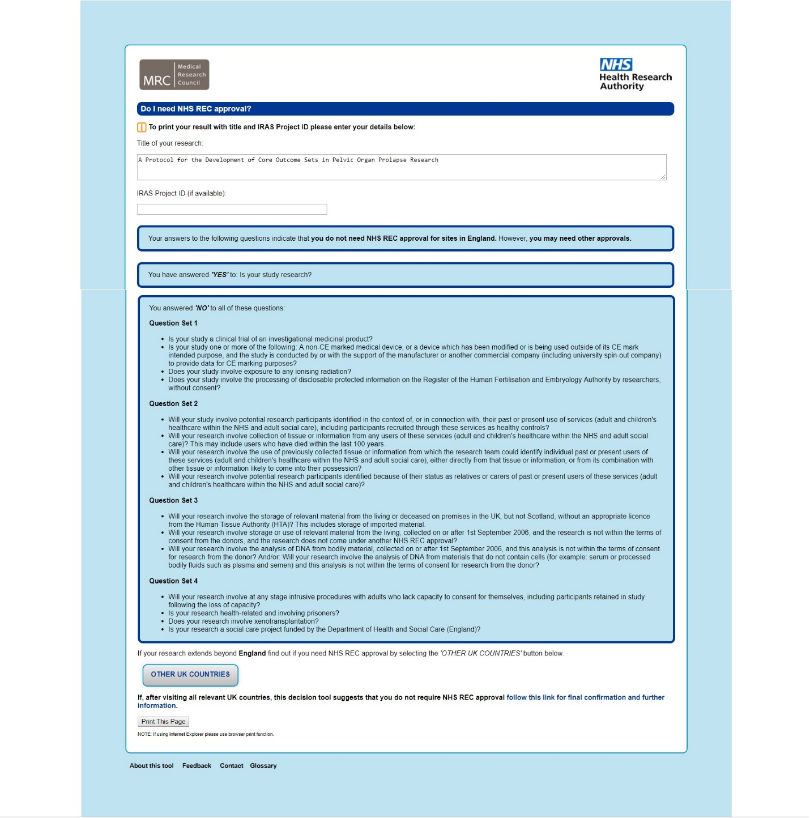
Dissemination 11 Describe any plans to communicate the results to study participants and COS users, inclusive of methods and timing of dissemination
We aim to include our COS into our website )i-chorus.org) the CROWN Initiative website and list of COS, and the COMET Initiative directory. We will also invite journal editors to participate and assist in disemintation.
Dissemination and implementation of the resulting COS within an international context will be promoted. Embedding the COS for POP within future clinical trials, systematic reviews, and clinical practice guidelines could make a profound contribution to advancing the value of research in informing and guiding clinical practice, enhancing patient care and improving outcomes. The infrastructure created by developing a COS for POP could be leveraged in other settings, for example, further advancing research priorities and clinical practice guideline development.
ADMINISTRATIVE INFORMATION
Funders 12 Describe sources of funding, role of funders
No funding was received for this work.
Conflicts of interest
13 Describe any potential conflicts of interest within the study team and how they will be managed
The authors declare no conflict of interests.

